Supporting: MSFKB3004 Conduct on-site adjustments to cabinets and components

Section 2 Assignment: Using tools on-site
Name |  | Date

Task 1
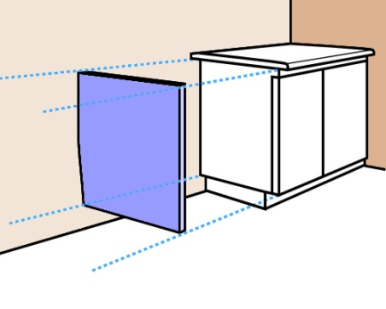
This task deals with two scenarios where a vanity cabinet is being installed in the corner of a bathroom. In both instances the rear wall is out of plumb, but in opposite directions.
You have decided to hide the tapered gap between the cabinet and wall by fitting an end panel (the blue panel shown in the diagram at right).
The end panel will go from the underside of the bench top to the bottom of the cabinet, above the kickboard. It will fit hard against the wall and finish flush with the front of the door. Although the wall is out of plumb, it is flat, so the tapered side of the end panel will form a straight line and won’t need to be scribed.
You take the following measurements relating to the cabinet, and produce a quick detail drawing of each scenario (as shown in the diagrams on the next page).
- Bench top thickness: 35 mm
- Height from top of kickboard to top of bench top: 765 mm
- Width of cabinet (including door): 450 mm
- Bench top overhang: 25 mm
For each scenario:
- draw the shape of the end panel in the blank space beside the detail drawing
- mark in the width of the panel at the top, width at the bottom, and height
- mark the two corners that are at right angles.

Scenario 1
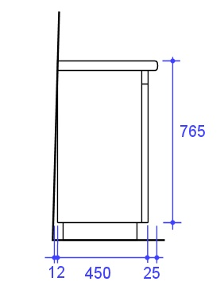

Scenario 2
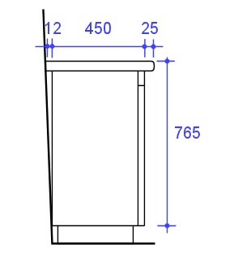

Task 2: Power tools
Choose either an electric plane or a jig saw and write up a safe operating procedure (SOP) using the template provided on the following page.
You may consult the manufacturer's instruction booklet or an existing workplace SOP for more information, and include some of that material in your SOP.
Note that a ‘Sample SOP’ is provided in the Learner Guide and is also linked to the ‘Assignment’ page on the website.

SOP for:

Potential hazards and safety controls
Hazard | Control

Pre-start checks

Operational procedure

